SAP 调用 外围系统RESTful接口

目录
1、 json序列化和反序列化的函数 1
2、 API接口的调用函数 2
3、 get、post方式传输数据 5
4、 代码案例。 5

json序列化和反序列化的函数

使用类/UI2/CL_JSON的方法，进行序列和反序列。
*内表转JSON接口数据
CALL METHOD /UI2/CL_JSON=>SERIALIZE
EXPORTING
DATA = GT_DATA
* COMPRESS = ABAP_FALSE
* NAME =
* PRETTY_NAME = ABAP_FALSE
* TYPE_DESCR =
RECEIVING
R_JSON = GV_JSON.
WRITE : GV_JSON.
*JSON数据转为内表数据
CALL METHOD /UI2/CL_JSON=>DESERIALIZE
EXPORTING
JSON = GV_JSON
* PRETTY_NAME = ABAP_FALSE
CHANGING
DATA = GT_DATA.

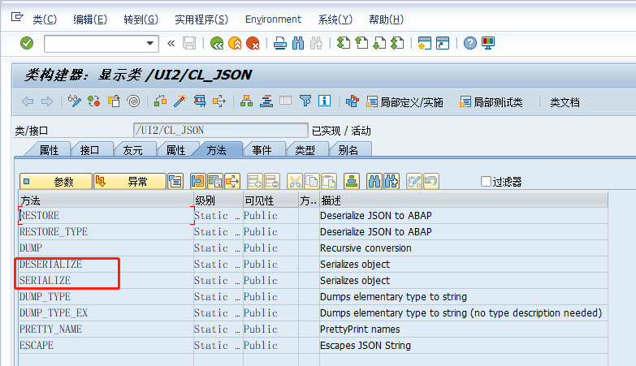

API接口的调用函数
使用类CL_HTTP_CLIENT的方法进行调用和传输参数、接收返回参数。

"实例化1个 IF_HTTP_CLIENT 的对象得到HTTP_CLIENT
CL_HTTP_CLIENT=>CREATE_BY_URL(
EXPORTING URL = LV_URL "输入参数
IMPORTING CLIENT = LO_HTTP_CLIENT ).
LO_HTTP_CLIENT->PROPERTYTYPE_LOGON_POPUP = LO_HTTP_CLIENT->CO_DISABLED.
CALL METHOD LO_HTTP_CLIENT->AUTHENTICATE(
EXPORTING
USERNAME = ''
PASSWORD = ''
* LANGUAGE = 'E'
).

"设置某个特定的header field的值
LO_HTTP_CLIENT->REQUEST->SET_HEADER_FIELD(
EXPORTING
NAME = '~SERVER_PROTOCOL'
VALUE = 'HTTP/1.1' ).
"设置某个特定的header field的值
CALL METHOD LO_HTTP_CLIENT->REQUEST->SET_HEADER_FIELD
EXPORTING
NAME = 'Content-Type'
VALUE = 'application/JSON; charset=utf-8'.
"设置某个特定的header field的值
LO_HTTP_CLIENT->REQUEST->SET_HEADER_FIELD(
EXPORTING
NAME = 'ACCEPT'
VALUE = '*/*' ).

"设置http请求的方法GET 或者 POST
CALL METHOD LO_HTTP_CLIENT->REQUEST->SET_METHOD( 'POST' ).
"设置http body
DATA S_BODYDATA TYPE STRING VALUE '{"key1":"value1"}'.
CALL METHOD LO_HTTP_CLIENT->REQUEST->SET_CDATA
EXPORTING
DATA = S_BODYDATA. "输入参数
"dispatch of data
CALL METHOD LO_HTTP_CLIENT->SEND
EXCEPTIONS
HTTP_COMMUNICATION_FAILURE = 1
HTTP_INVALID_STATE = 2.

"receipt of http response
CALL METHOD LO_HTTP_CLIENT->RECEIVE
EXCEPTIONS
HTTP_COMMUNICATION_FAILURE = 1
HTTP_INVALID_STATE = 2
HTTP_PROCESSING_FAILED = 3.
"获取response中的http的body内容
DATA GV_JSON TYPE STRING.
GV_JSON = LO_HTTP_CLIENT->RESPONSE->GET_CDATA( ). "执行结果
WRITE GV_JSON.

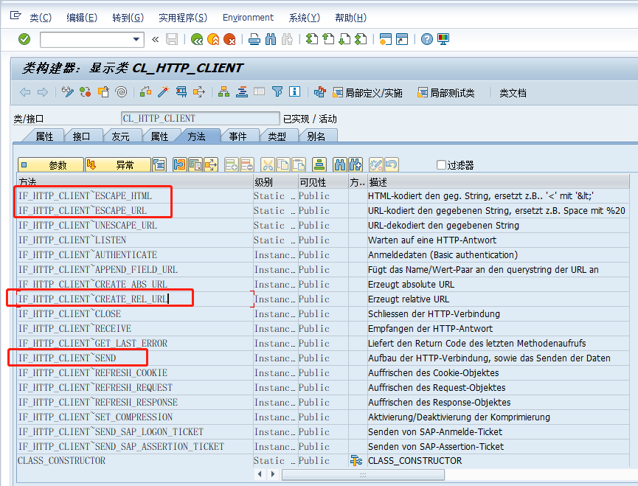

get、post方式传输数据

"设置http请求的方法 POST
CALL METHOD LO_HTTP_CLIENT->REQUEST->SET_METHOD( 'POST' ).
"设置http body
DATA S_BODYDATA TYPE STRING VALUE '{"key1":"value1"}'.
CALL METHOD LO_HTTP_CLIENT->REQUEST->SET_CDATA
EXPORTING
DATA = S_BODYDATA. "输入参数
"dispatch of data
CALL METHOD LO_HTTP_CLIENT->SEND
EXCEPTIONS
HTTP_COMMUNICATION_FAILURE = 1
HTTP_INVALID_STATE = 2.

* 设置HTTP接口地址,并把参数拼接在路径后。通过get的方式传输过去
LV_URL_PAR = '"a我会很好b"'.
CALL METHOD cl_HTTP_CLIENT=>IF_HTTP_CLIENT~ESCAPE_URL
EXPORTING
UNESCAPED = LV_URL_PAR
RECEIVING
ESCAPED = LV_URL_PAR.
LV_URL = 'http://172.16.8.49:8080/helloworld/?name='.
CONCATENATE LV_URL LV_URL_PAR INTO LV_URL.

代码案例。
